ABIT Past Sponsors & Partners
Association of Budding Information Technocrats (ABIT), RGIT

Overview
This document compiles the comprehensive roster of all 39 past sponsors, corporate partners, and workshop collaborators of ABIT (Rajiv Gandhi Institute of Technology, Mumbai). It includes each organization's domain, sponsorship/partnership role, and their official logo.

Master Directory of Sponsors & Partners
# | Sponsor / Company Name | Partnership Category / Role | Sector / Industry | Official Logo
1 | Collegepond | Overseas Education Partner | Higher Education & Study Abroad | 
2 | Infotech Academy | Workshop Partner (WordPress Web Development) | IT Training & Education
3 | North Star Consultancy | Webinar Partner (Portfolio Building) | Career & Overseas Consulting | 
4 | Talenthome Solutions | Seminar Partner (Web Development) | IT Solutions & Training | 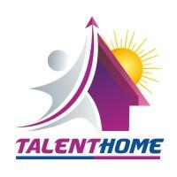
5 | Finance Cafe | Webinar Partner (Stock Market Trading) | Financial Education & Wealth Advisory | 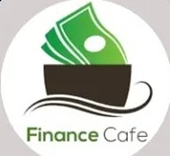
6 | Vidyalankar | Seminar Partner (Foreign Studies) | Higher Education & Coaching | 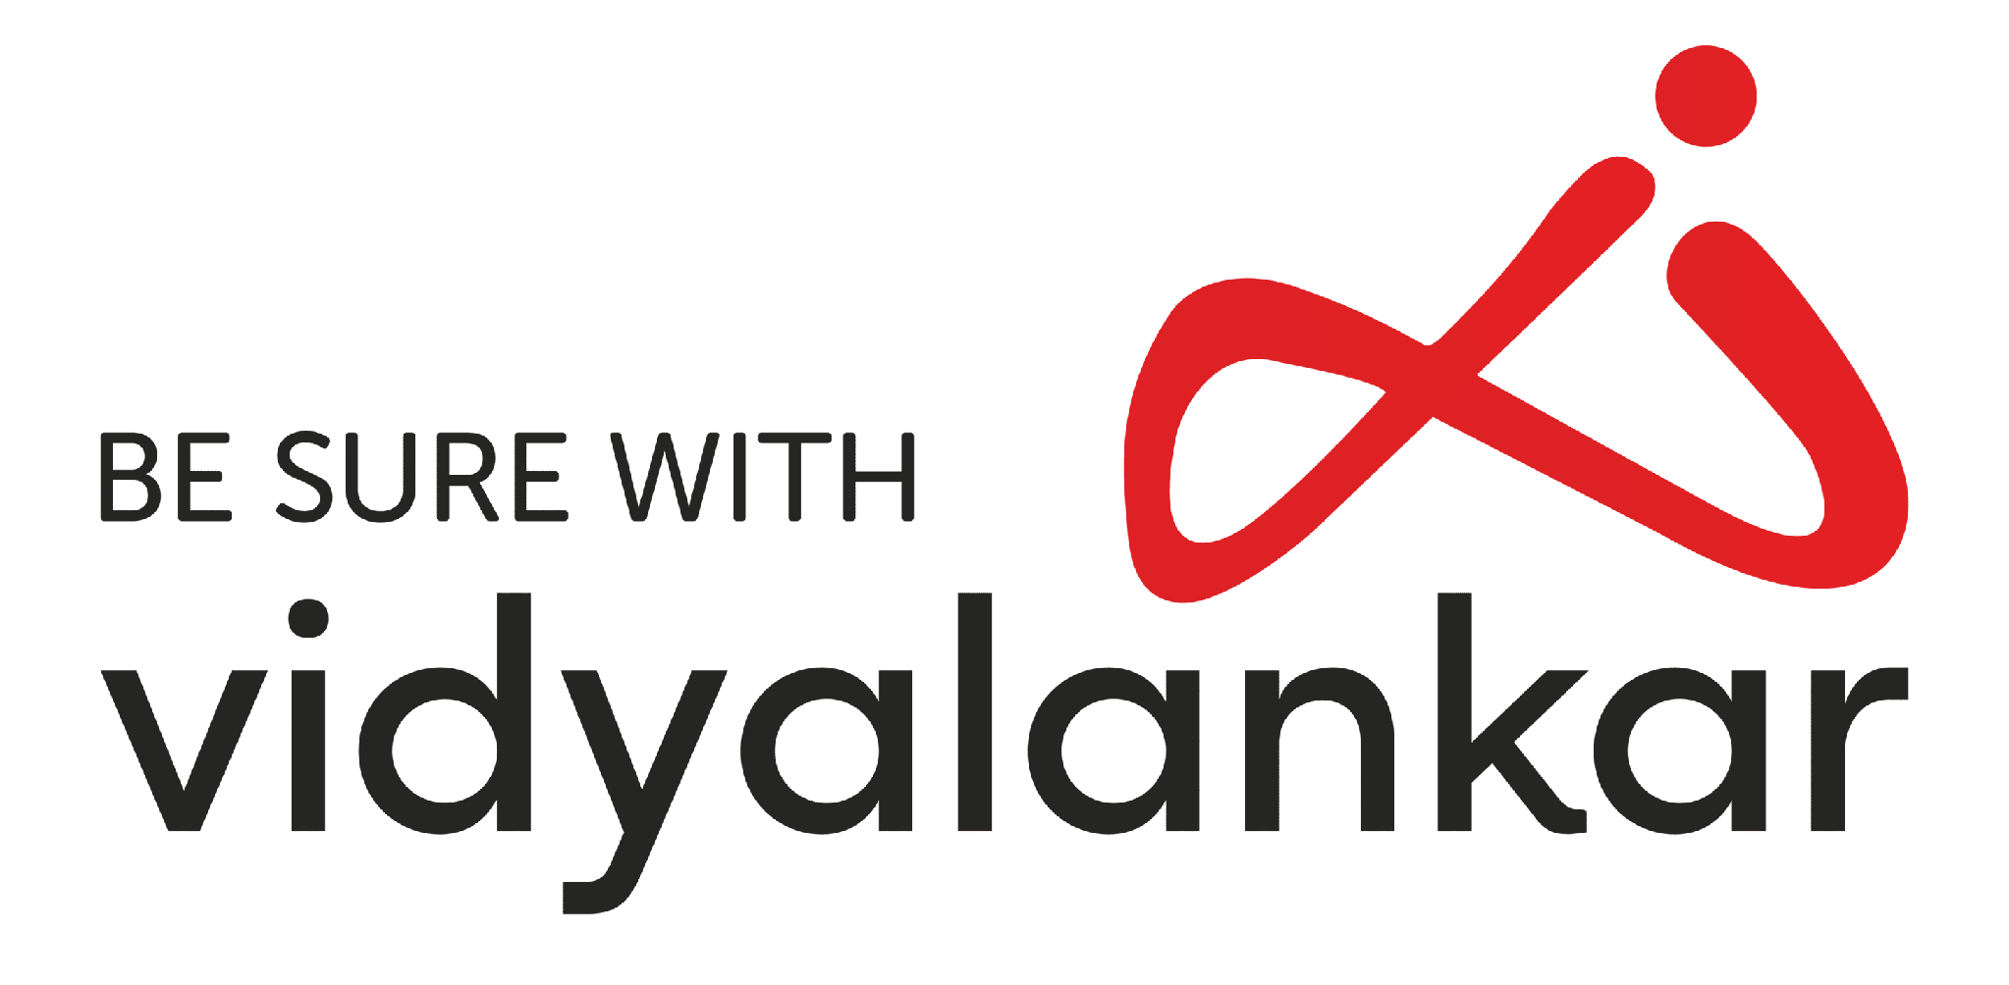
7 | Temples of India | Internship Partner | Cultural Heritage & Content Platform | 
8 | GeeksforGeeks | Technical & Coding Partner | EdTech & Computer Science | 
9 | Try Catch Classes | Title Sponsor | IT Training & Certification | 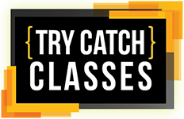
10 | Inflow | Cybersecurity Workshop Partner | Enterprise IT & Information Integrity | 
11 | The VFX Institute by Visual Birds Studio | Creative & Media Partner | Animation, VFX & Visual Arts | 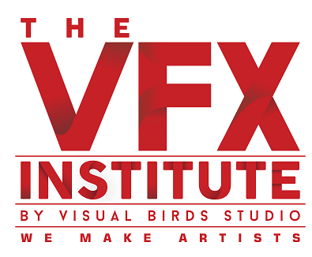
12 | Vision Trading | Financial Education Partner | Stock Trading & Financial Markets | 
13 | Shivtara Enterprises | Industrial / Event Partner | Manufacturing & Industrial Solutions | 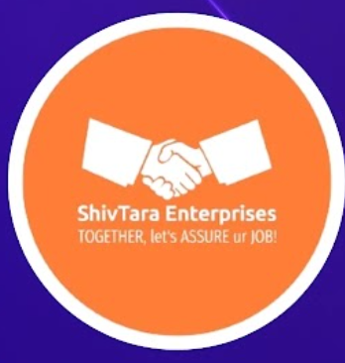
14 | Coding Ninjas | Coding & EdTech Partner | Programming Education & Upskilling | 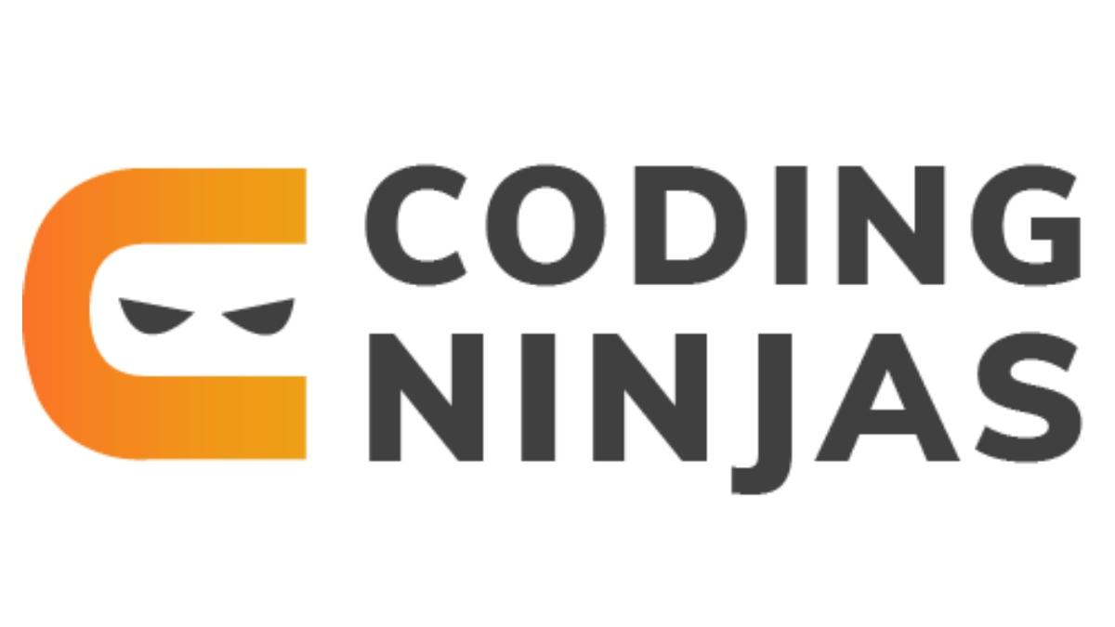
15 | Riya Study Abroad | Study Abroad Partner | Global Overseas Consulting | 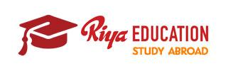
16 | Hacktify | Cyber Security & Training Partner | Ethical Hacking & Infosec | 
17 | RHI Magnesita | Corporate / Industrial Sponsor | Refractory Products & Solutions | 
18 | Cloud Counselage | IT & Cloud Partner | Cloud Computing & Career Consulting | 
19 | Vold Energy Drinks | Beverage Partner | Energy Beverages & FMCG | 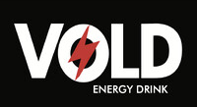
20 | Intervue.io | Technical Assessment Partner | Live Interview & Hiring Platform | 
21 | Watermelon Gang Marketing Agency | Marketing & Social Media Partner | Digital Marketing & Creative Strategy | 
22 | Markin’it | Branding & Design Partner | Creative Marketing & Merchandise | 
23 | Mannasrekha Enterprises | Communication Partner | Telecommunications & Services | 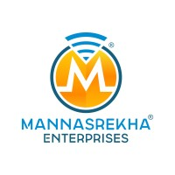
24 | Suraj Lama Momos | Food Partner | Fast Food & Quick Service Restaurant | 
25 | Pizza Hut | Food Partner | Pizza Chain & Fast Food | 
26 | D Lakhani Hospitality | Hospitality Partner / Special Thanks | Hospitality, Dining & Banquets | 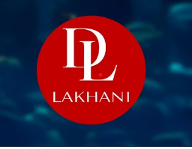
27 | Travotic Holidays | Travel Partner | Tours, Travel & Holiday Logistics | 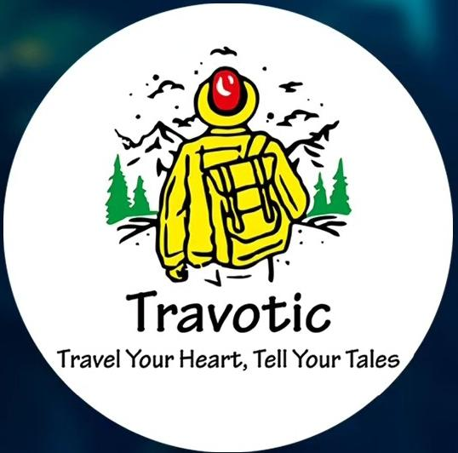
28 | 369 Group of Companies | Title Sponsor | Conglomerate & Corporate Ventures | 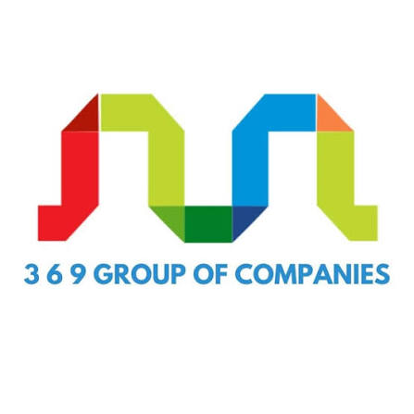
29 | VS Sahil | Creative / Media Partner | Media Production & Influencer | 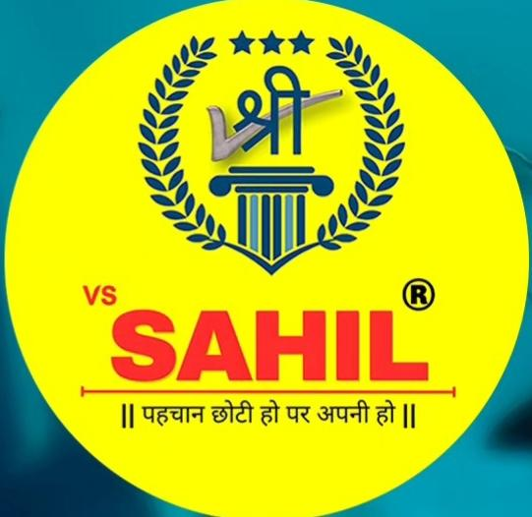
30 | Moon Thrifts | Accessory Partner | Sustainable Fashion & Thrift Store | 
31 | Cherry & Chocolatte | Cafe & Gifting Partner | Bakery, Confectionery & Cafe | 
32 | Black Simba Energy Drink | Beverage Partner | Energy Drinks & Beverages | 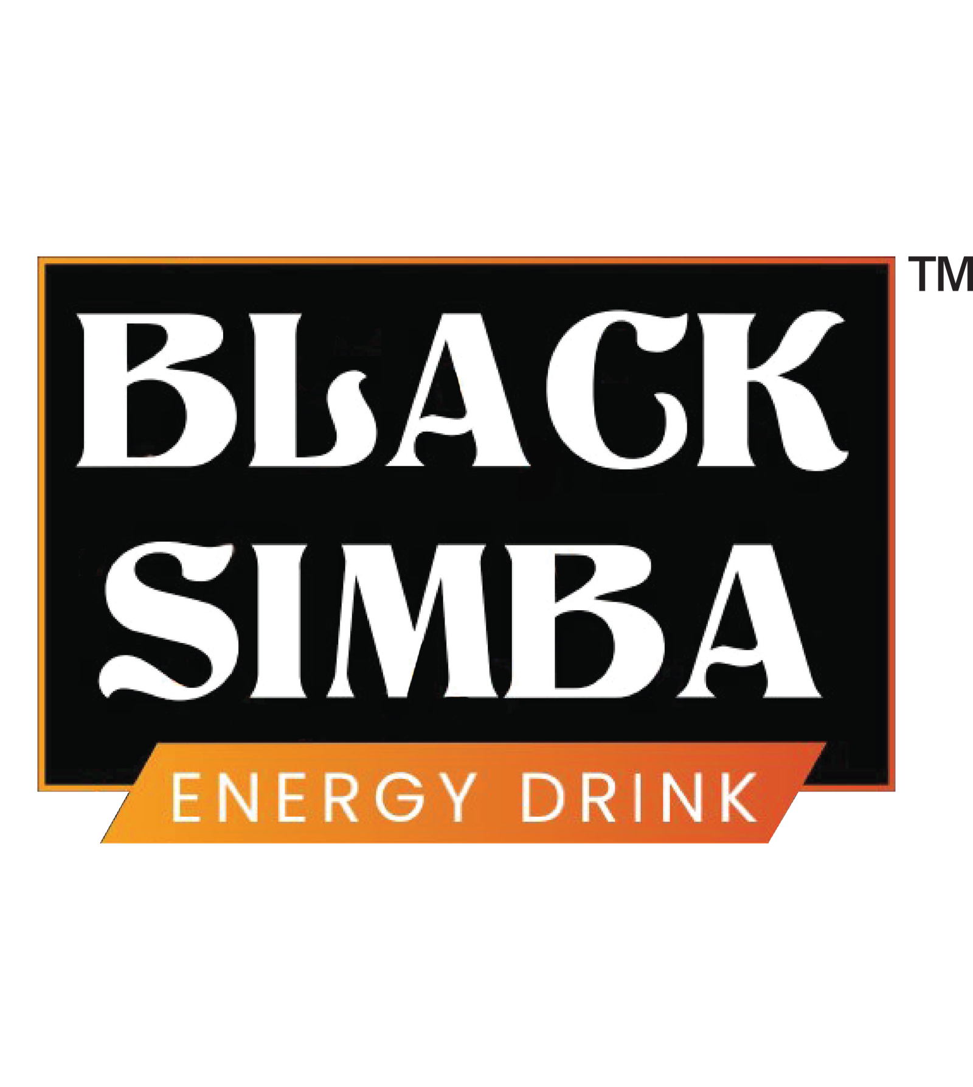
33 | The Belgian Waffle Co. | Food Partner | Waffles, Desserts & Quick Service | 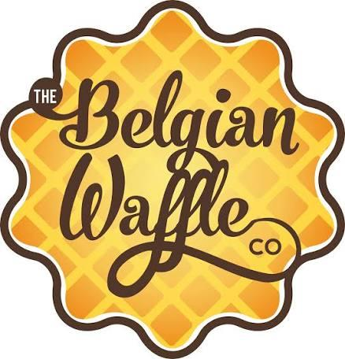
34 | Domino's Pizza | Food Partner | Pizza Chain & Fast Food | 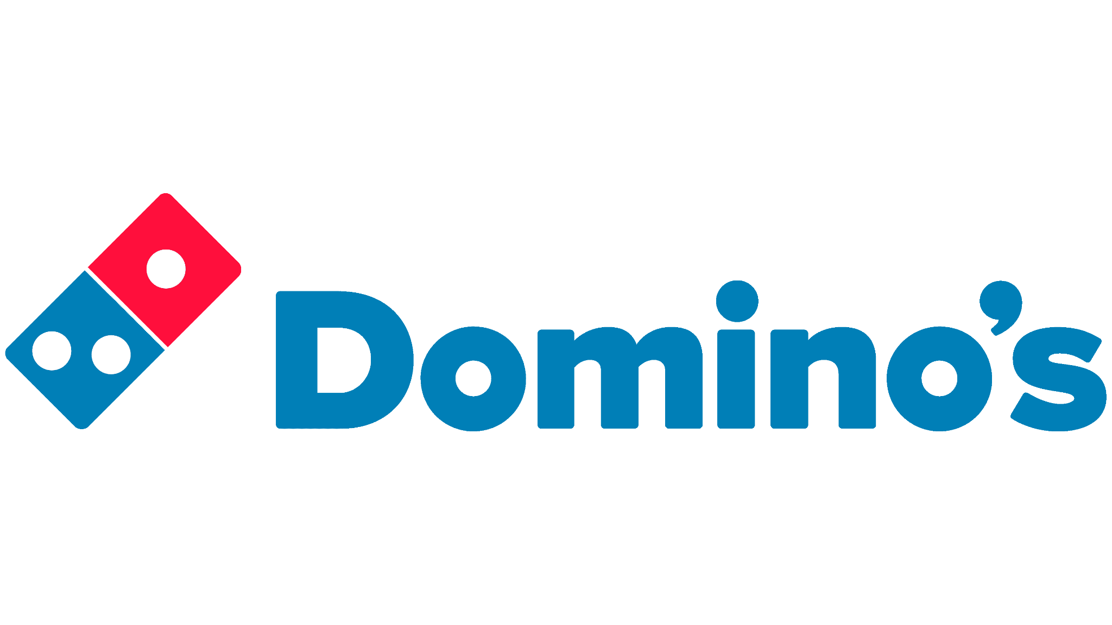
35 | VeeFly | Advertising Partner | Video Marketing & YouTube Promotion | 
36 | Leverage Edu | Knowledge Partner | Study Abroad & Higher Education | 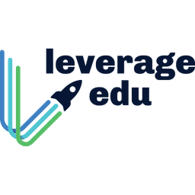
37 | Imperial Overseas | Foreign Studies Partner | Overseas Education Consultancy | 
38 | TechBairn | Tech Partner | Emerging Tech Training & Upskilling | 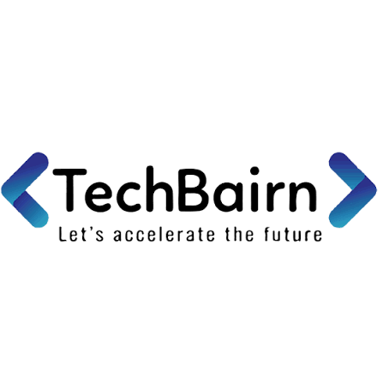
39 | Uptiq.ai | AI & Innovation Partner | Artificial Intelligence & SaaS Platform | 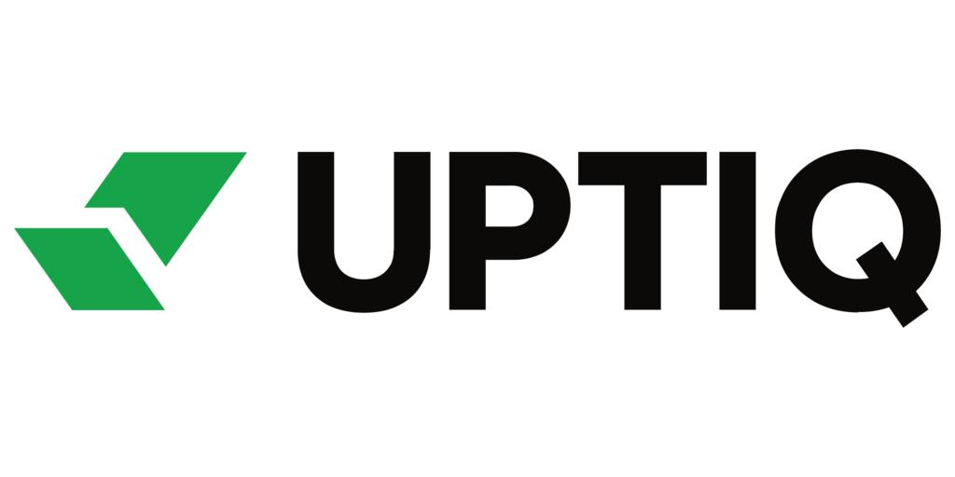

Categorized Sponsor Breakdown

1. Title Sponsors & Core Corporate Backers
- 369 Group of Companies (Title Sponsor, Synergy Fest 2023-24)
- Try Catch Classes (Title Sponsor & IT Training Partner)
- RHI Magnesita (Industrial & Corporate Partner)

2. Education, Upskilling & Technical Partners
- GeeksforGeeks (Technical Content & Coding Partner)
- Coding Ninjas (Programming Education Partner)
- TechBairn (Emerging Tech & ML Workshop Partner)
- Inflow (Cybersecurity & Information Integrity Workshop)
- Hacktify (Ethical Hacking & Cybersecurity Partner)
- Infotech Academy (WordPress & Web Development Workshop)
- Talenthome Solutions (Web Development Offline Seminar)
- Cloud Counselage (Cloud Computing & Advisory)
- Intervue.io (Technical Hiring & Mock Assessment Partner)
- Uptiq.ai (AI & SaaS Technology Partner)

3. Study Abroad & Overseas Education Partners
- Collegepond (Overseas Education & Admissions)
- Vidyalankar (Foreign Studies Seminar Partner)
- Leverage Edu (Knowledge Partner - Study Abroad)
- Imperial Overseas Educational Consultants (Foreign Studies Partner)
- North Star Consultancy (Portfolio Building for Global Universities)
- Riya Study Abroad (Global Admissions Consultancy)

4. Food, Beverage & Dining Partners
- Domino's Pizza (Food Partner)
- Pizza Hut (Food Partner)
- The Belgian Waffle Co. (Food Partner - Desserts)
- Suraj Lama Momos (Food Partner)
- Black Simba Energy Drink (Beverage Partner)
- Vold Energy Drinks (Hydration & Beverage Partner)
- Cherry & Chocolatte (Cafe & Gifting Partner)
- D Lakhani Hospitality (Hospitality & Event Catering)

5. Media, Marketing & Creative Partners
- VeeFly (Advertising & Video Promotion Partner)
- Watermelon Gang Marketing Agency (Digital Marketing & Outreach)
- Markin’it (Branding & Creative Services)
- The VFX Institute by Visual Birds Studio (Visual Arts & VFX Partner)
- VS Sahil (Media & Content Partner)

6. Travel, Lifestyle & Allied Services
- Travotic Holidays (Travel Partner)
- Mannasrekha Enterprises (Communication Partner)
- Moon Thrifts (Accessory Partner)
- Finance Cafe (Stock Market Trading & Finance Webinar)
- Vision Trading (Financial Markets Education)
- Temples of India (Internship Partner)
- Shivtara Enterprises (Industrial & Supply Partner)

